**Superstore Analysis Using Python (October 2024)**

This project analyzes a superstore dataset to identify trends and patterns, particularly during the Diwali festival season.

**Project Overview**

**1. Data Exploration**

I began by examining the dataset to understand the information contained in each column. This initial exploration helped me identify the structure and key features of the data.

**2. Data Cleaning**

Next, I performed data cleaning to prepare the dataset for analysis. This involved:

* Removing empty columns and null values.
* Changing data types for accurate analysis.

**3. Exploratory Data Analysis (EDA)**

I conducted exploratory data analysis to uncover insights and trends within the dataset:

* **Gender Distribution**: I created a plot using Seaborn that illustrates the number of purchases by gender. The analysis shows that female customers have made more purchases compared to their male counterparts.  
  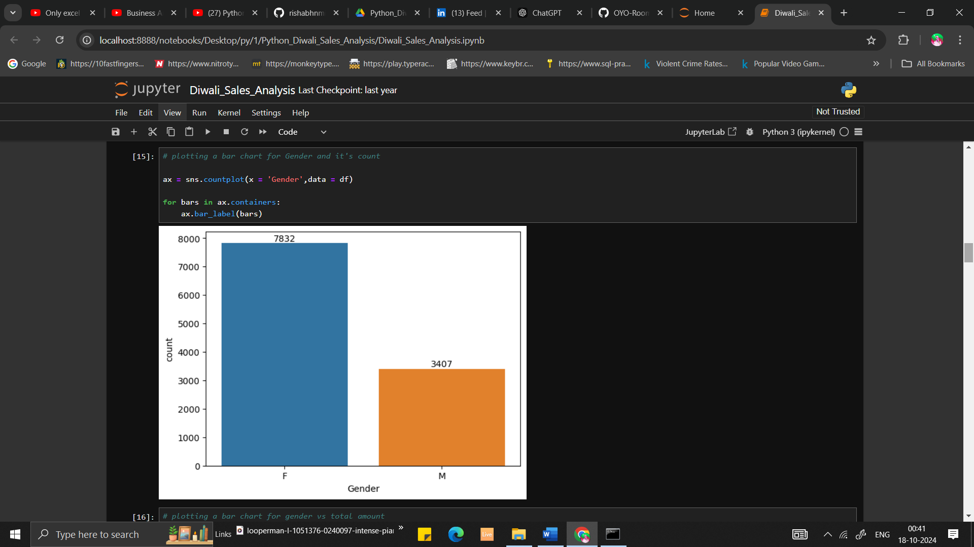  
  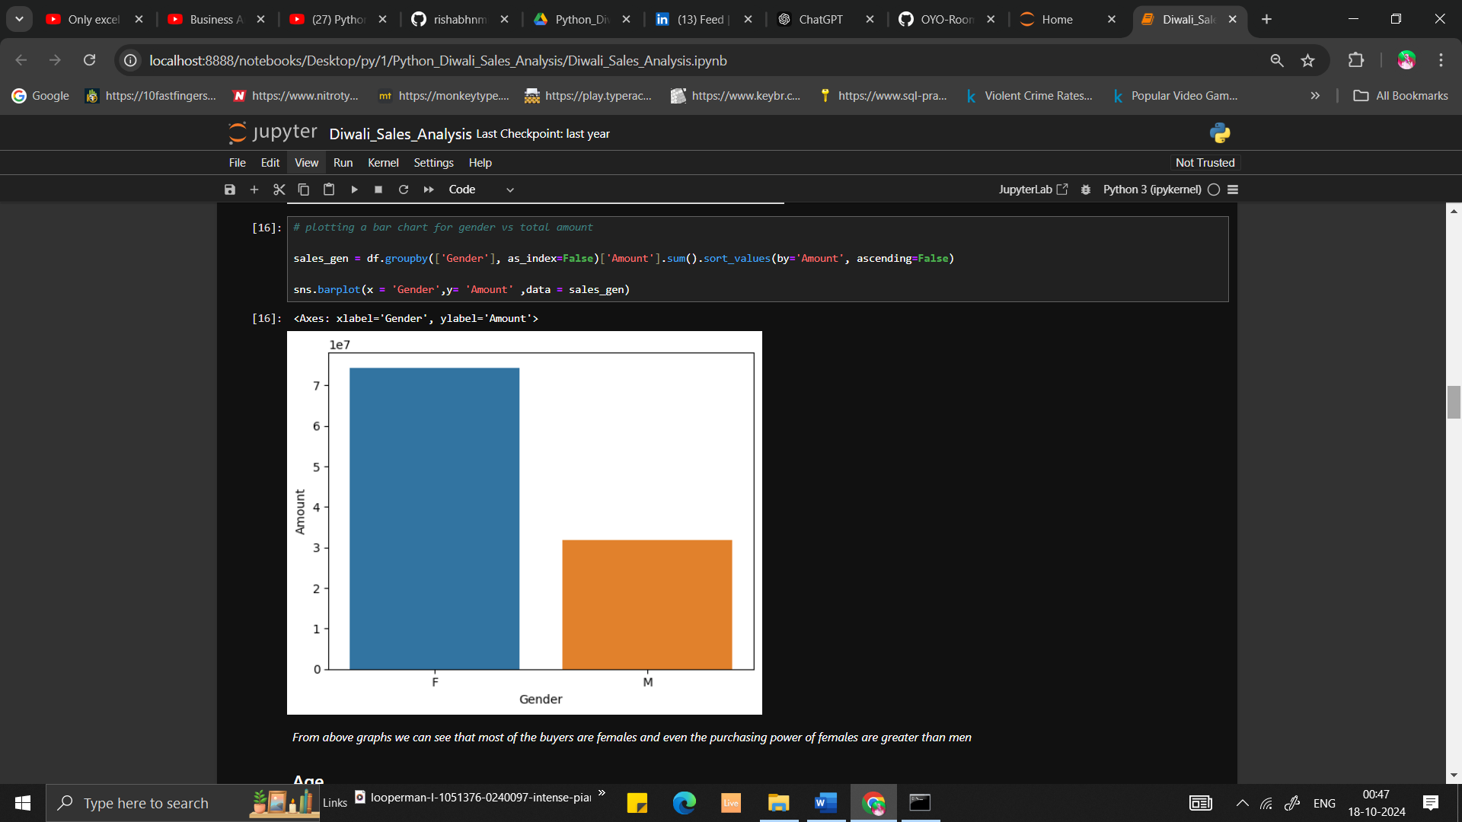  
    
  Plot 1 is based on count of orders  
  Plot 2 is based on Revenue
* **Age Group Analysis**: Based on age and gender, I found that the 26-35 age group has the highest number of buyers, with females being the top spenders in this category.  
  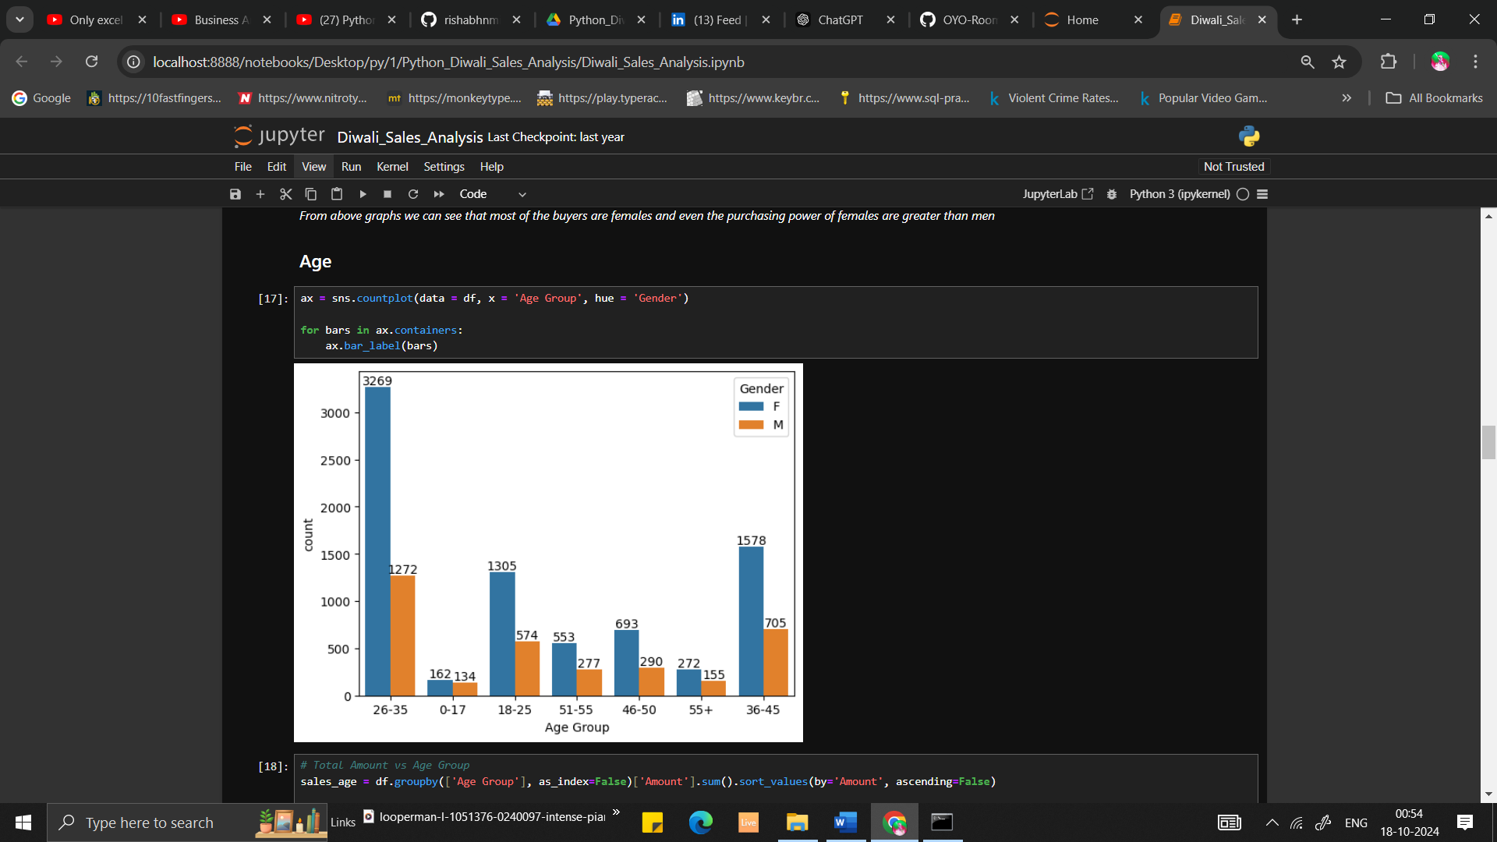
* **State-wise Orders**: I generated a bar plot to display the total number of orders by state. The results indicate that the majority of orders and total sales come from Uttar Pradesh, Maharashtra, and Karnataka.  
    
    
  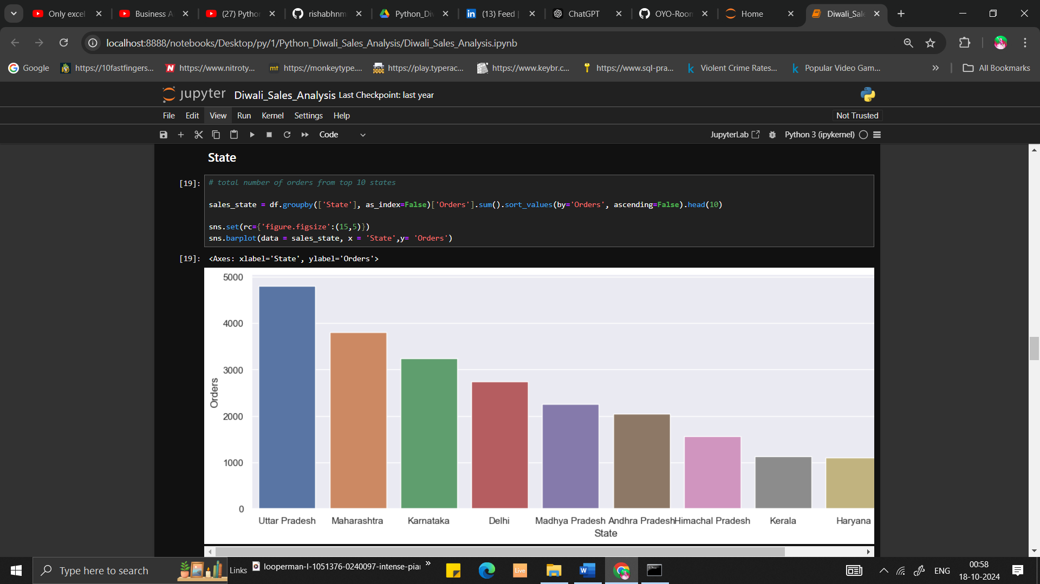
* **Product Category Revenue**: A simple bar plot illustrates the revenue generated by different product categories. Clothing emerges as the most ordered category, followed by food and electronics. However, when considering revenue amount, food generates the highest revenue, followed by clothing and electronics. 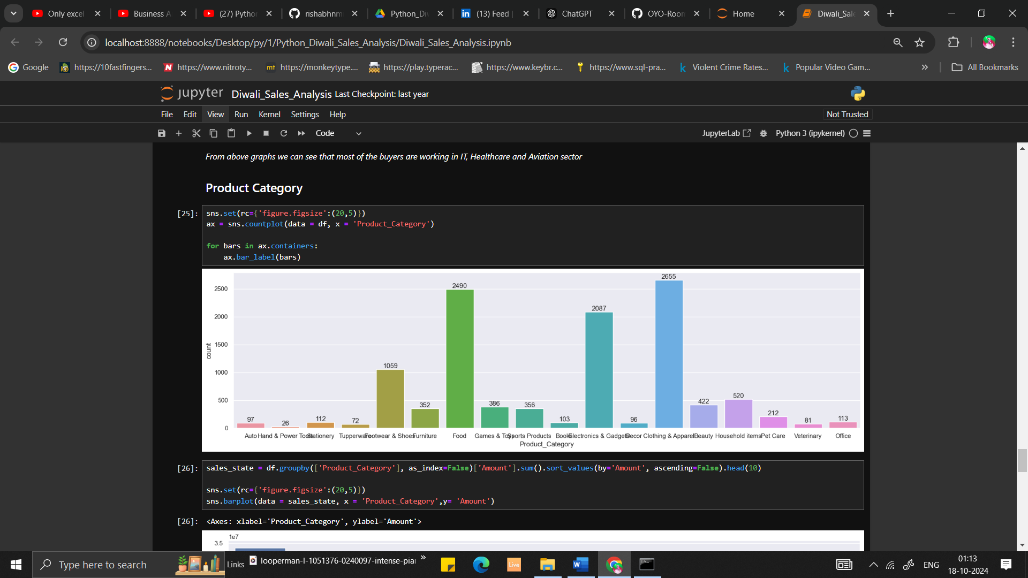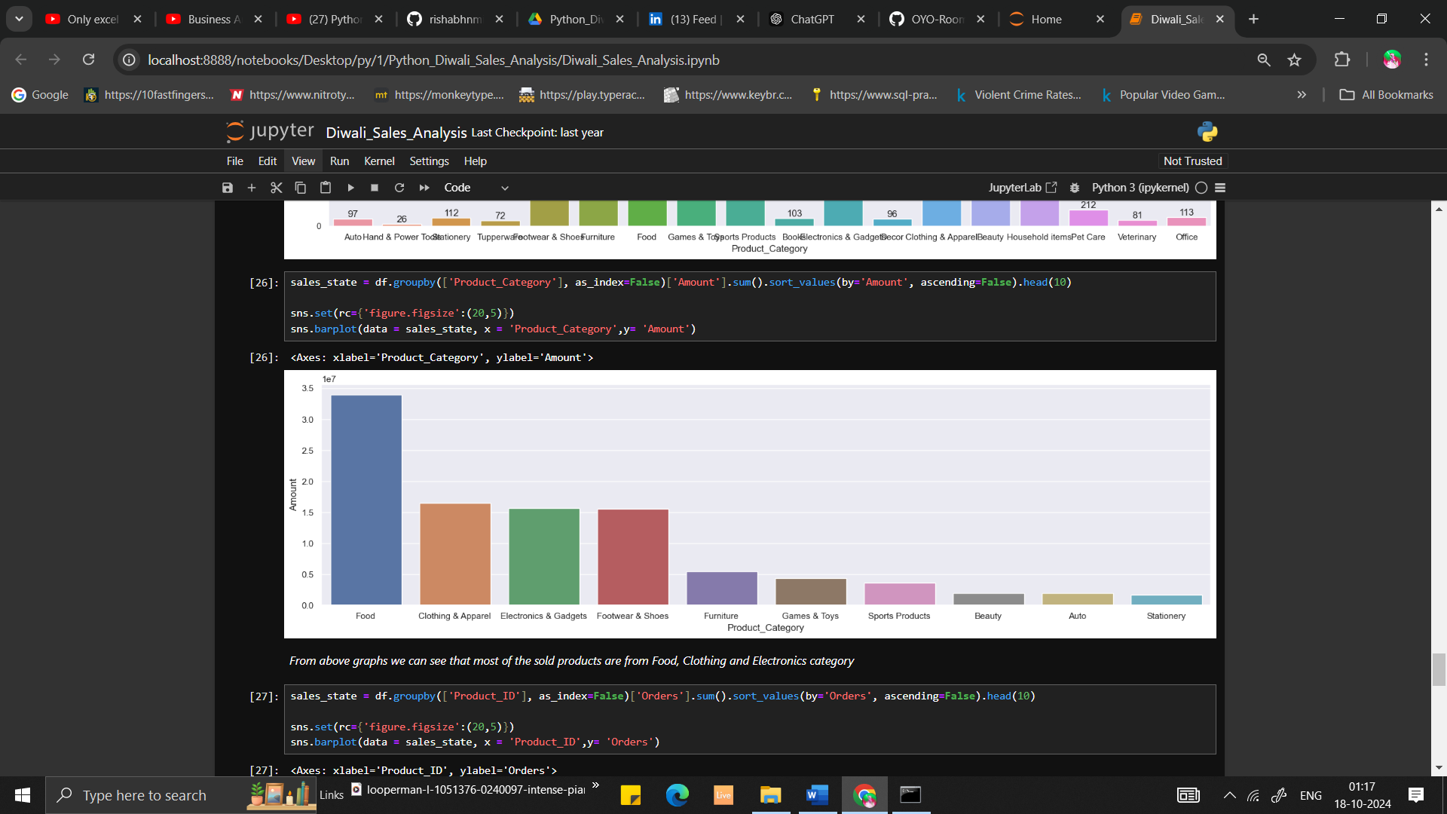

**Conclusion**

This analysis provides valuable insights into customer behavior and sales trends during Diwali, highlighting key demographics and product categories.